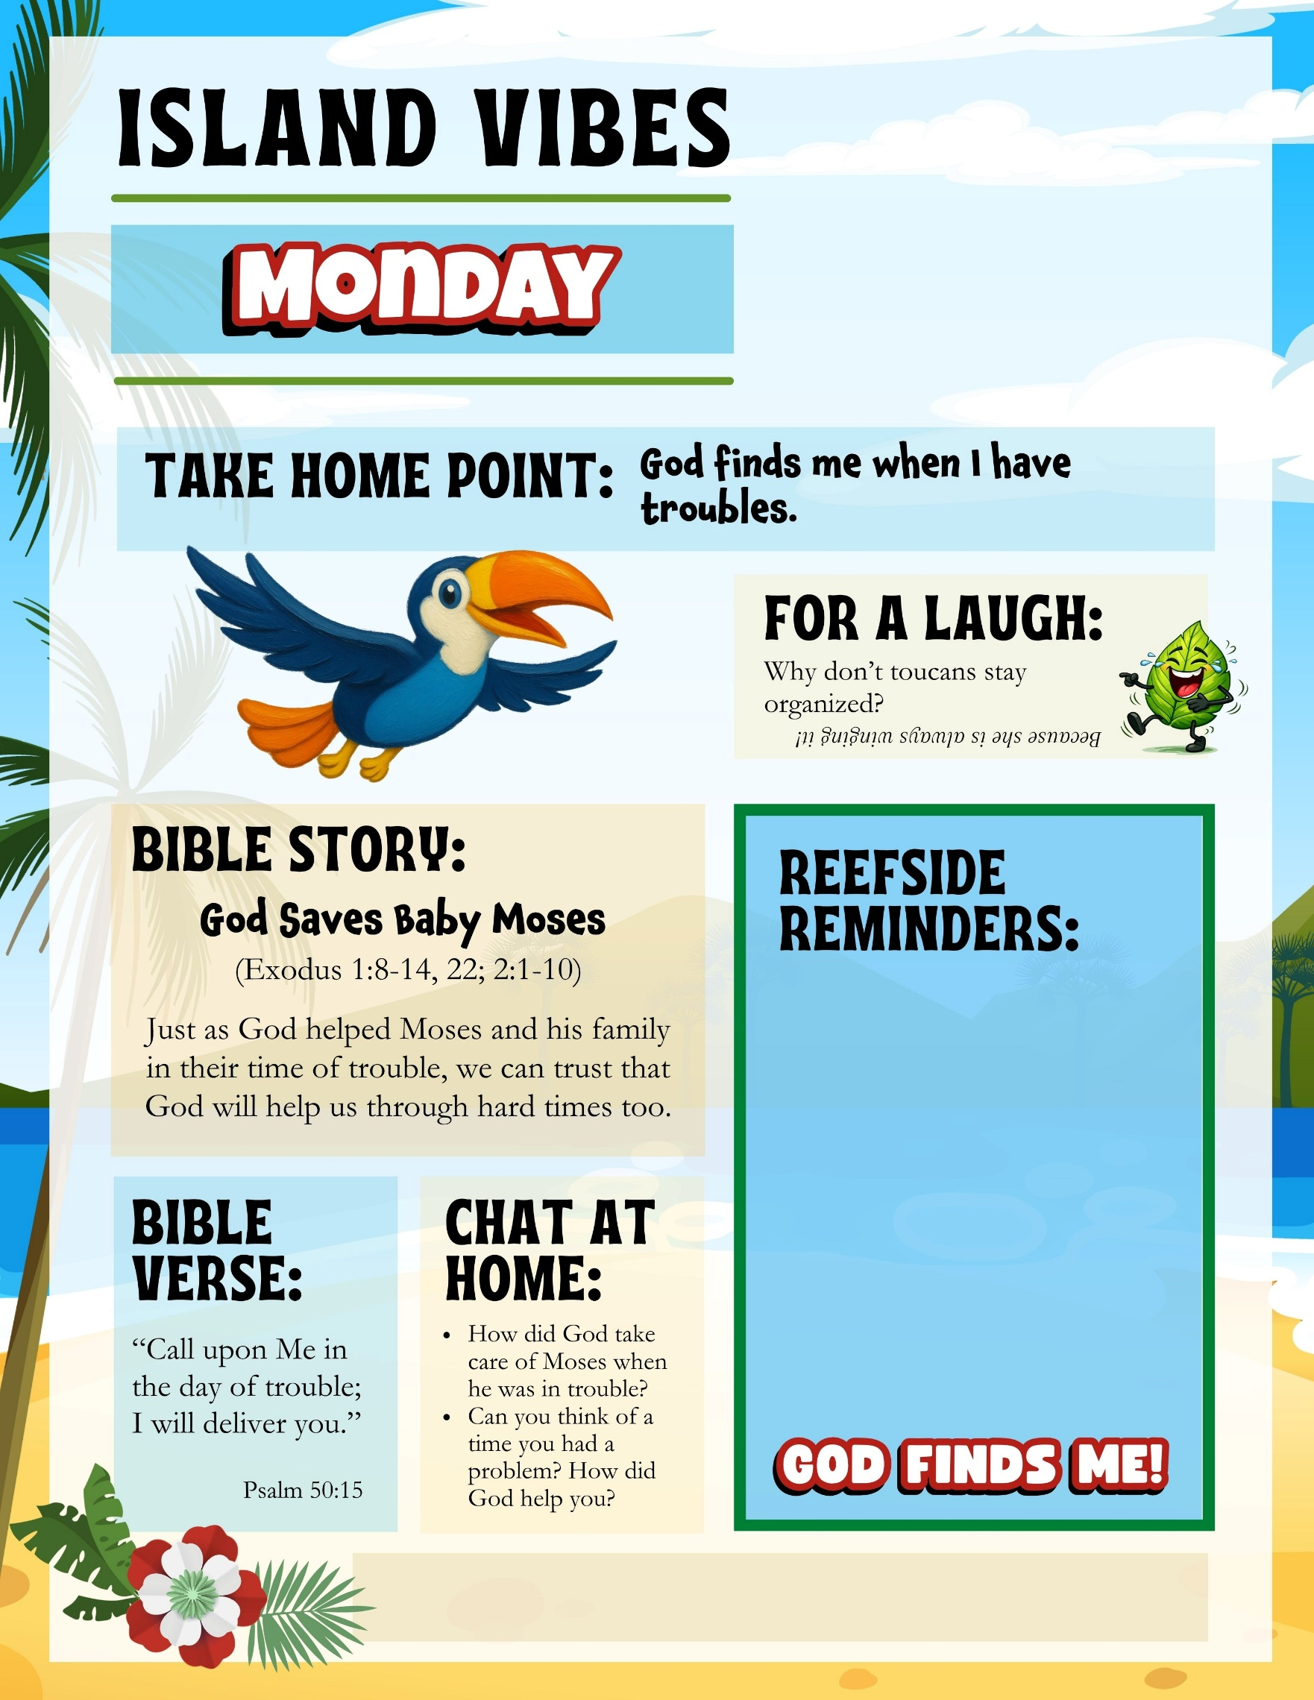
- Write important reminders for parents here…
- Announce your Celebration Sunday?
- Kids need to wear something special tomorrow? Let parents know.
- Remind parents about your missions project
Add your church name, website, phone, etc. here
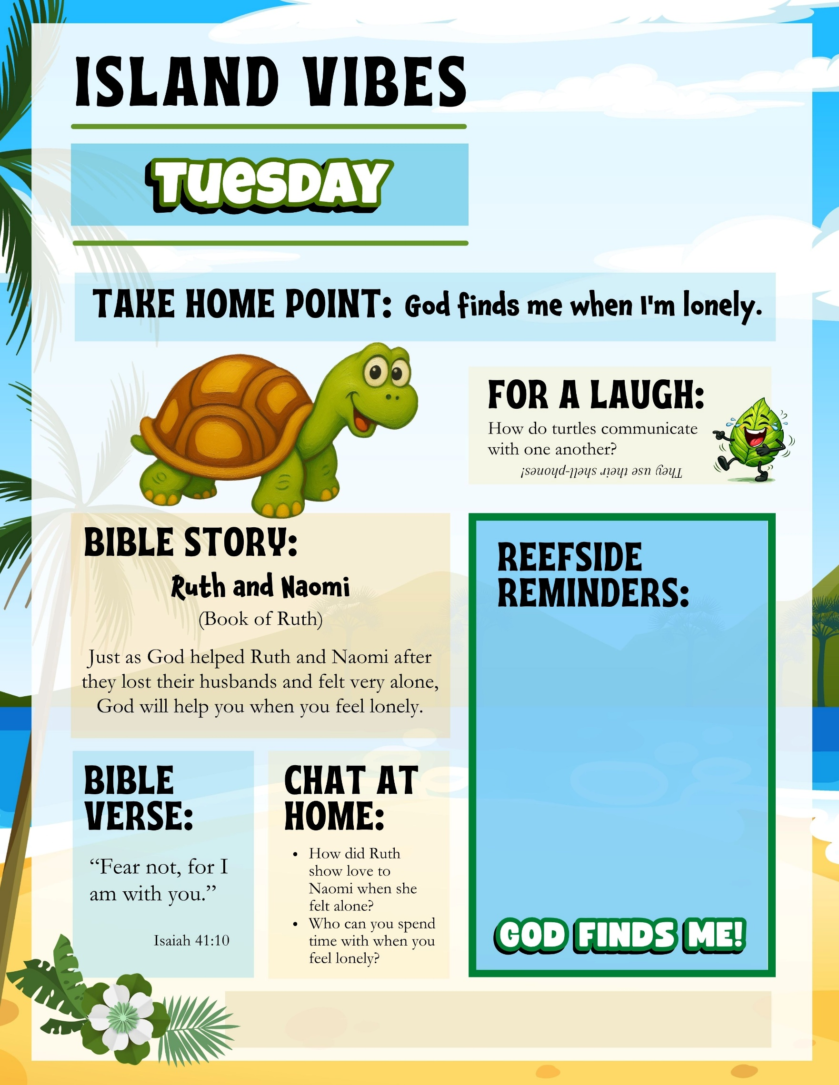
- Write important reminders for parents here…
- Announce your Celebration Sunday?
- Kids need to wear something special tomorrow? Let parents know.
- Remind parents about your missions project
Add your church name, website, phone, etc. here
- Write important reminders for parents here…
- Announce your Celebration Sunday?
- Kids need to wear something special tomorrow? Let parents know.
- Remind parents about your missions project
Add your church name, website, phone, etc. here
- Write important reminders for parents here…
- Announce your Celebration Sunday?
- Kids need to wear something special tomorrow? Let parents know.
- Remind parents about your missions project
Add your church name, website, phone, etc. here
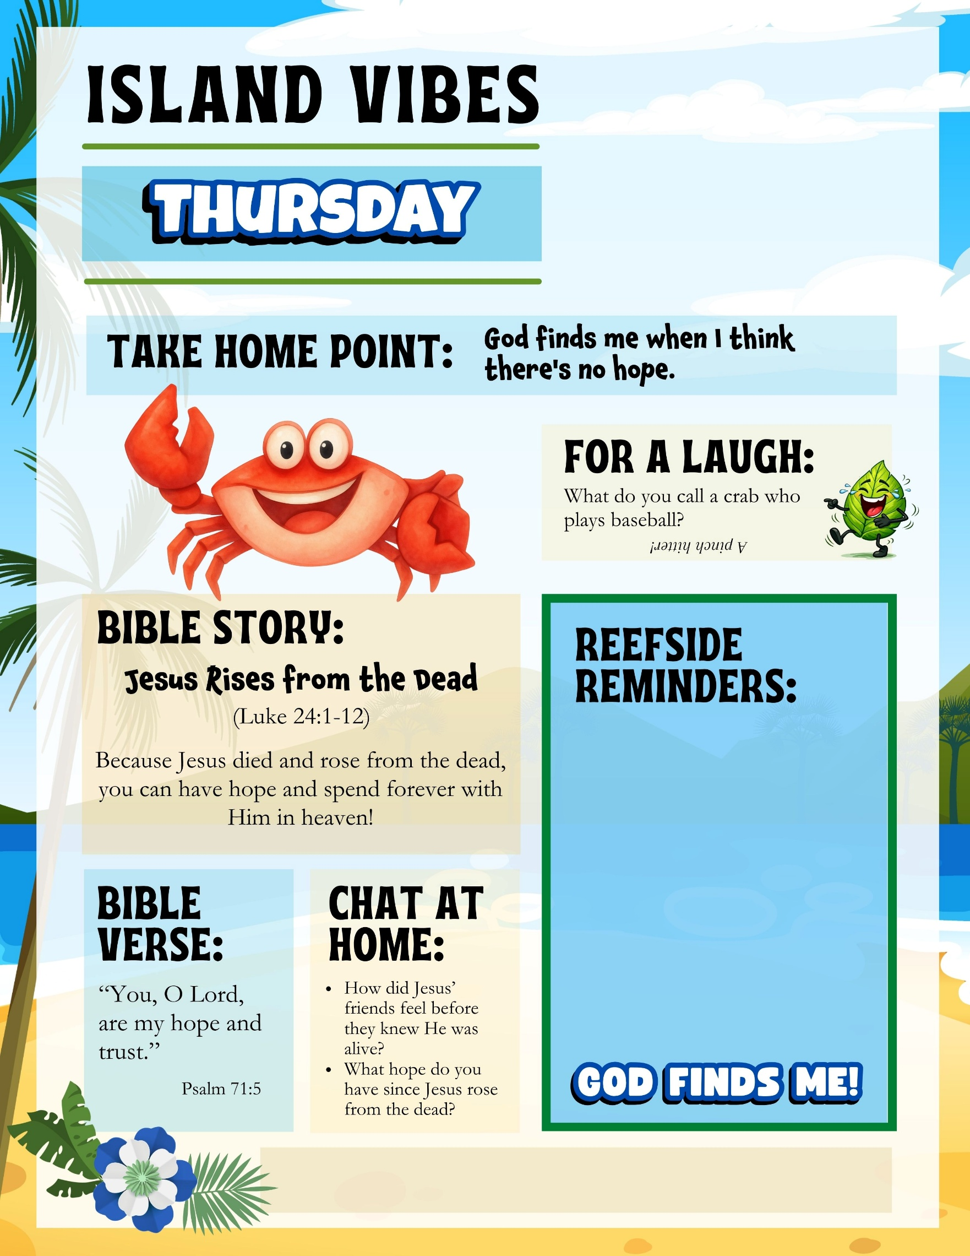
Add your church name, website, phone, etc. here
- Write important reminders for parents here…
- Announce your Celebration Sunday?
- Kids need to wear something special tomorrow? Let parents know.
- Remind parents about your missions project
- Write important reminders for parents here…
- Announce your Celebration Sunday?
- Kids need to wear something special tomorrow? Let parents know.
- Remind parents about your missions project
Add your church name, website, phone, etc. here
- Write important reminders for parents here…
- Announce your Celebration Sunday?
- Kids need to wear something special tomorrow? Let parents know.
- Remind parents about your missions project
Add your church name, website, phone, etc. here
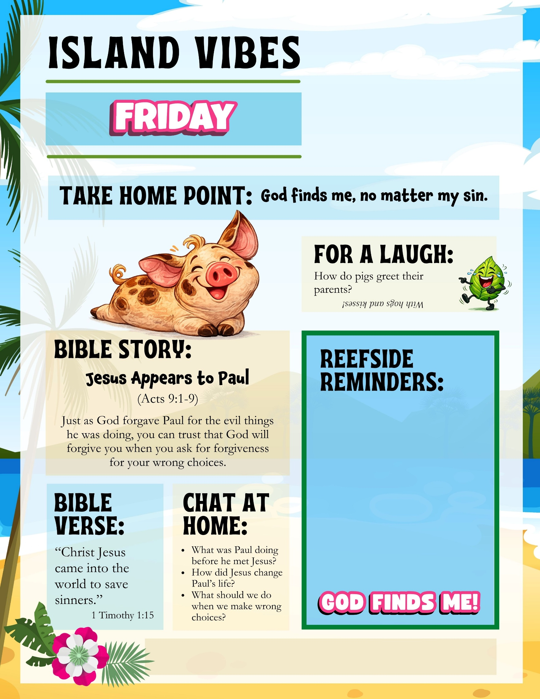
Add your church name, website, phone, etc. here
- Write important reminders for parents here…
- Announce your Celebration Sunday?
- Kids need to wear something special tomorrow? Let parents know.
- Remind parents about your missions project
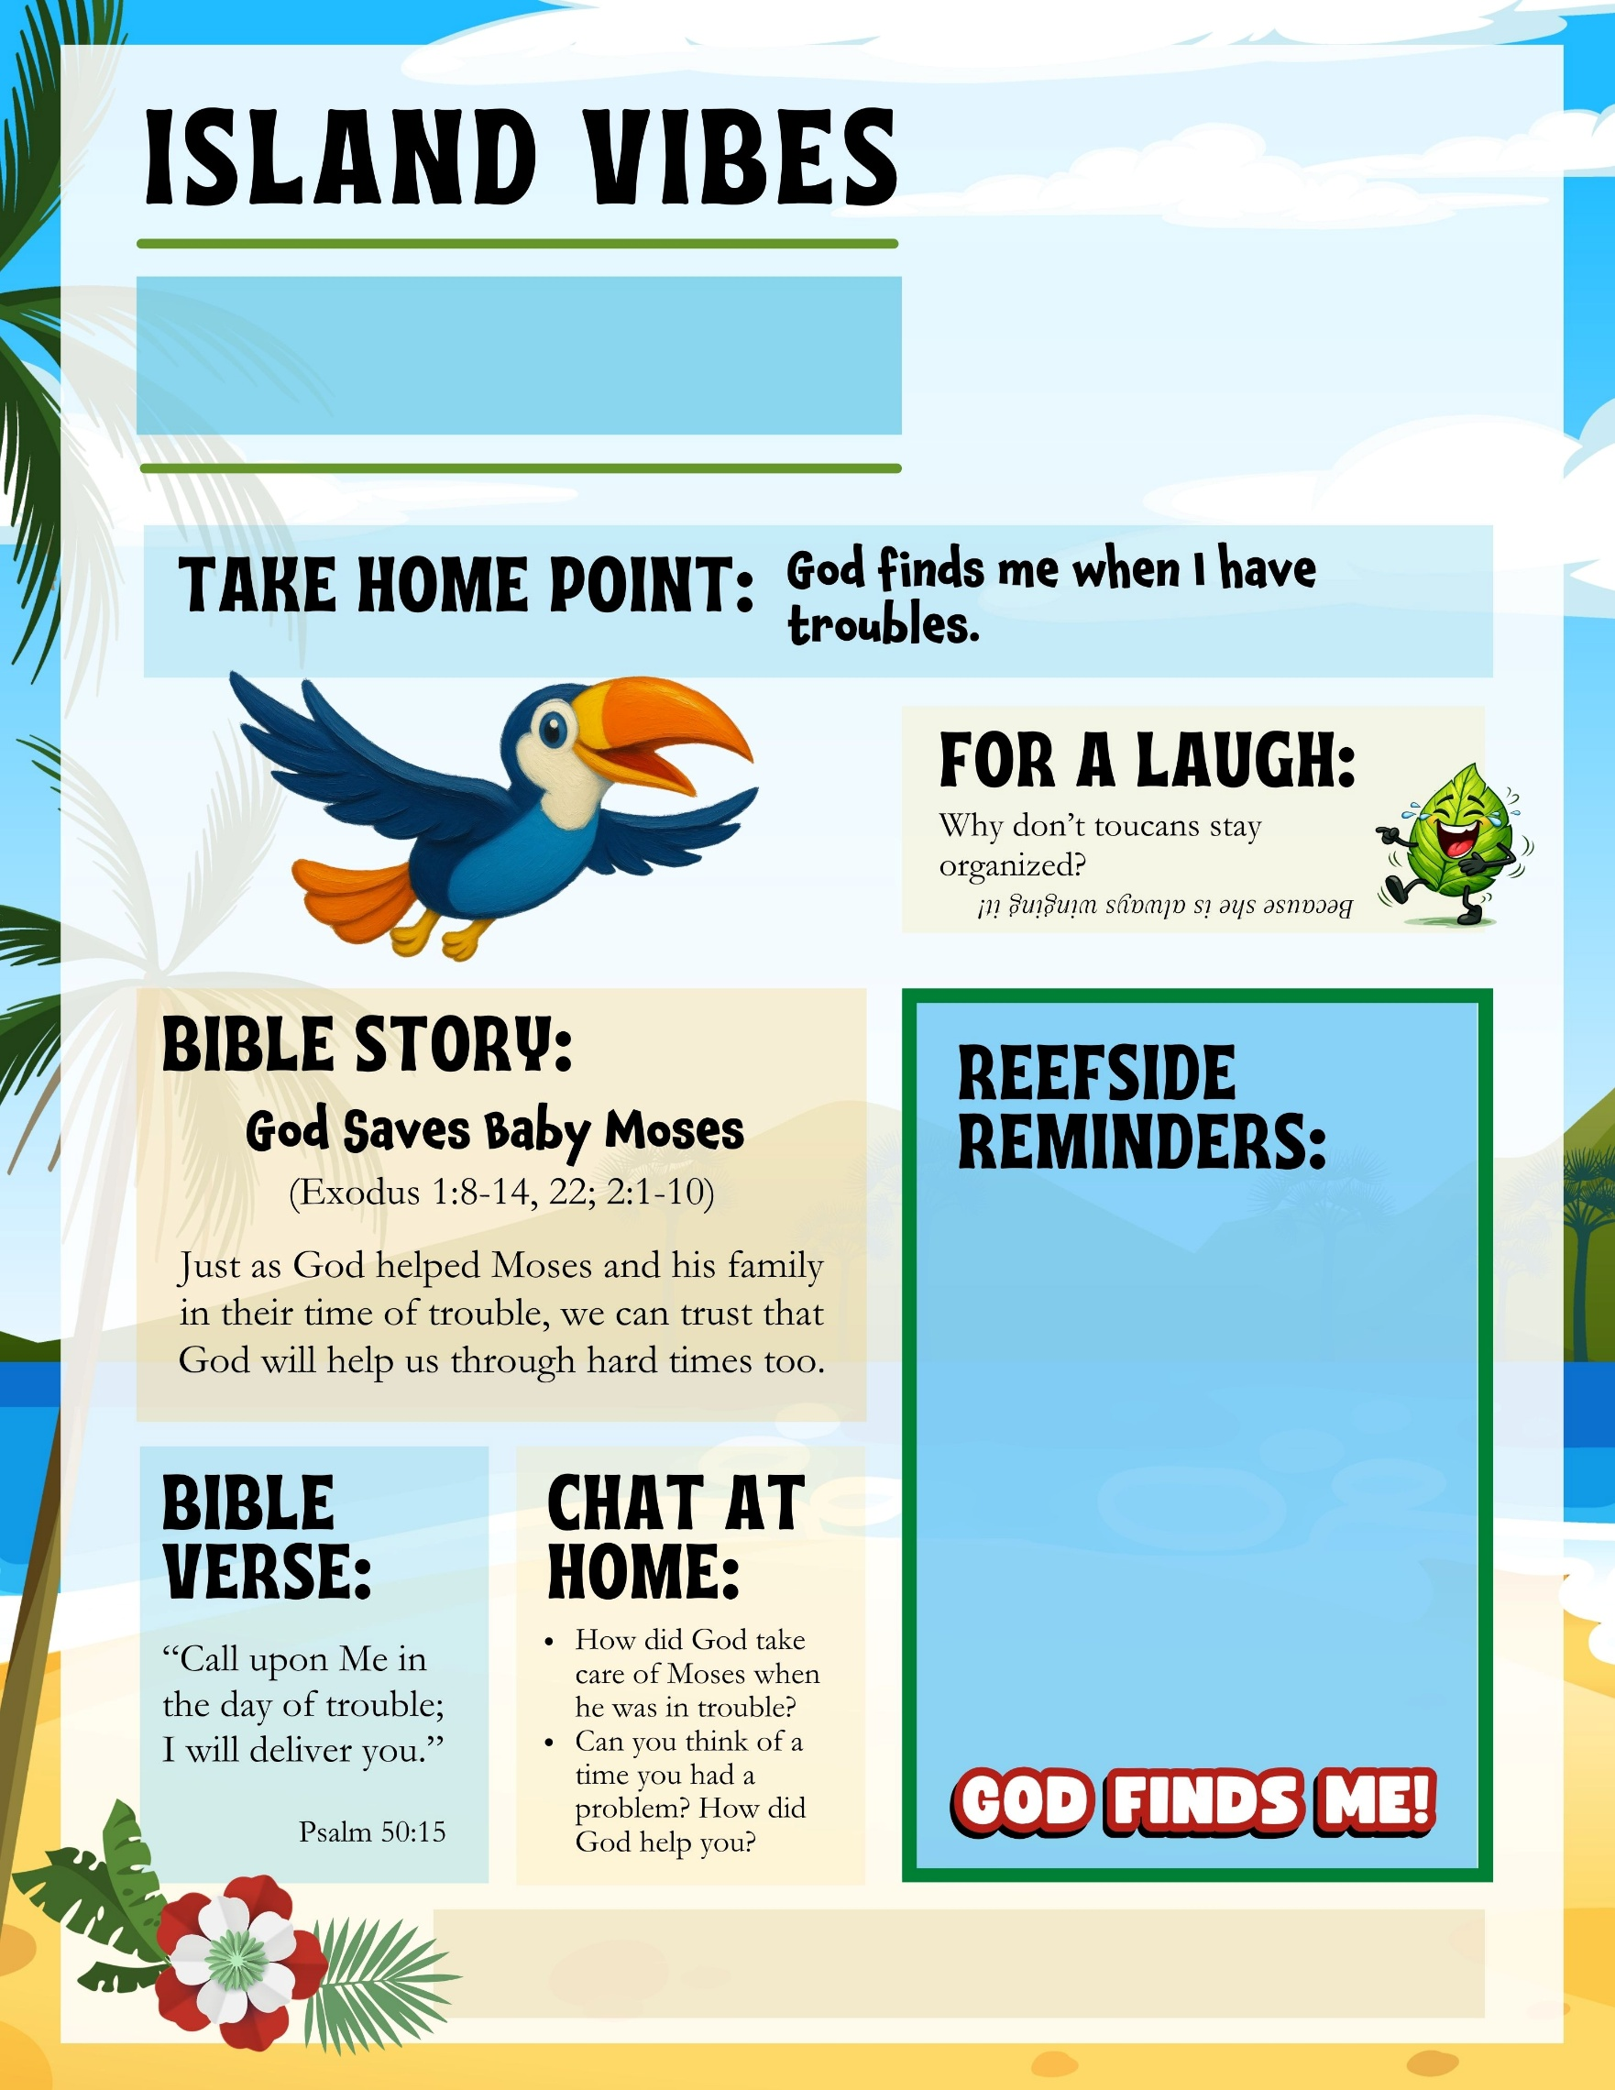
Add your church name, website, phone, etc. here
- Write important reminders for parents here…
- Announce your Celebration Sunday?
- Kids need to wear something special tomorrow? Let parents know.
- Remind parents about your missions project
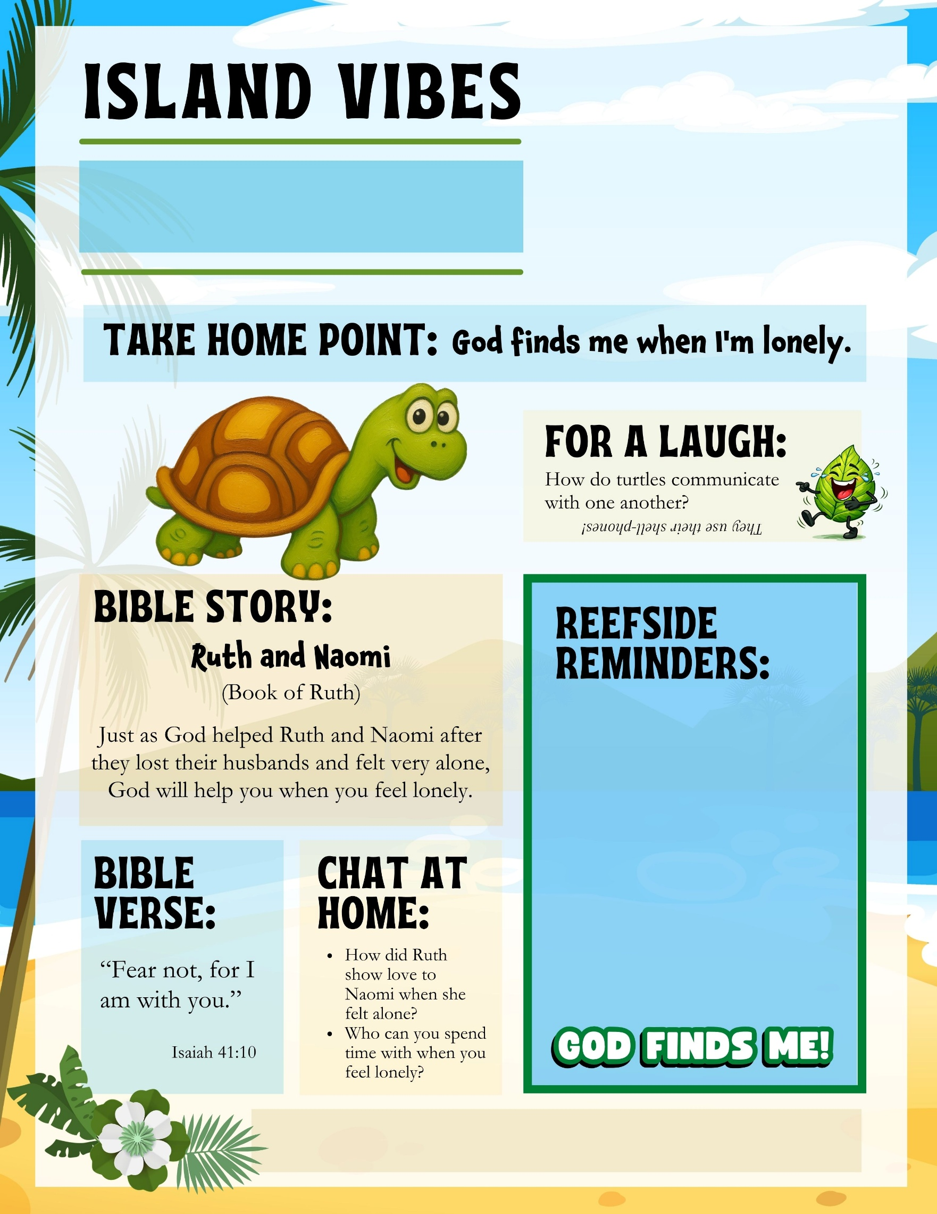
Add your church name, website, phone, etc. here
- Write important reminders for parents here…
- Announce your Celebration Sunday?
- Kids need to wear something special tomorrow? Let parents know.
- Remind parents about your missions project
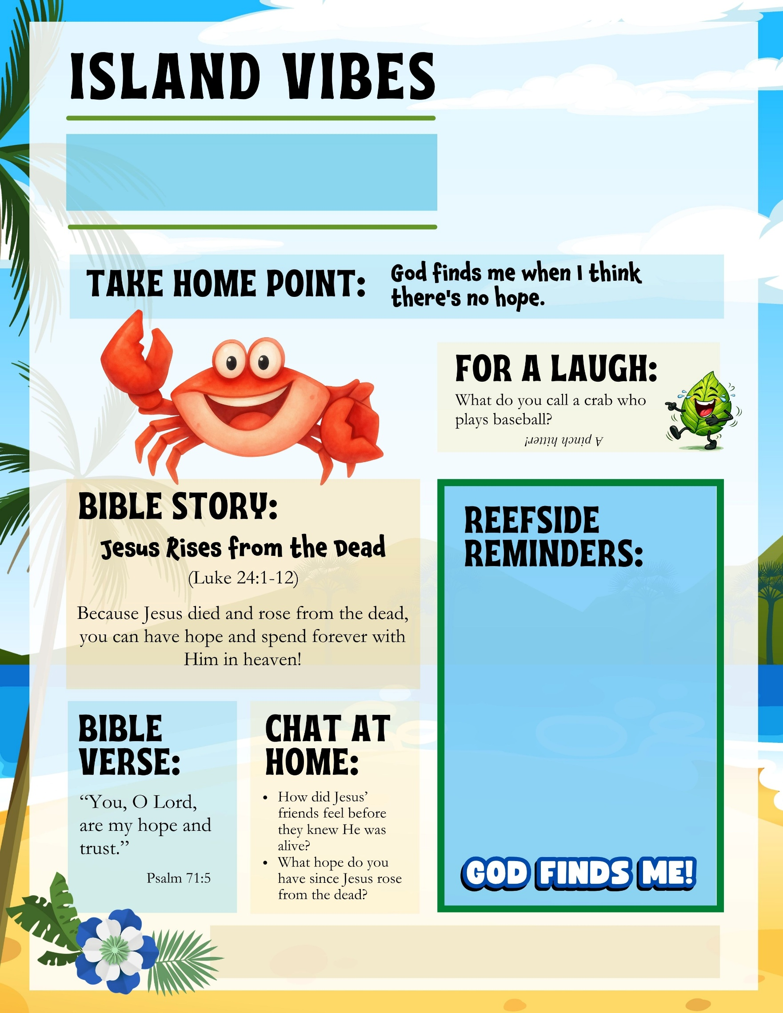
Add your church name, website, phone, etc. here
- Write important reminders for parents here…
- Announce your Celebration Sunday?
- Kids need to wear something special tomorrow? Let parents know.
- Remind parents about your missions project
- Write important reminders for parents here…
- Announce your Celebration Sunday?
- Kids need to wear something special tomorrow? Let parents know.
- Remind parents about your missions project
Add your church name, website, phone, etc. here
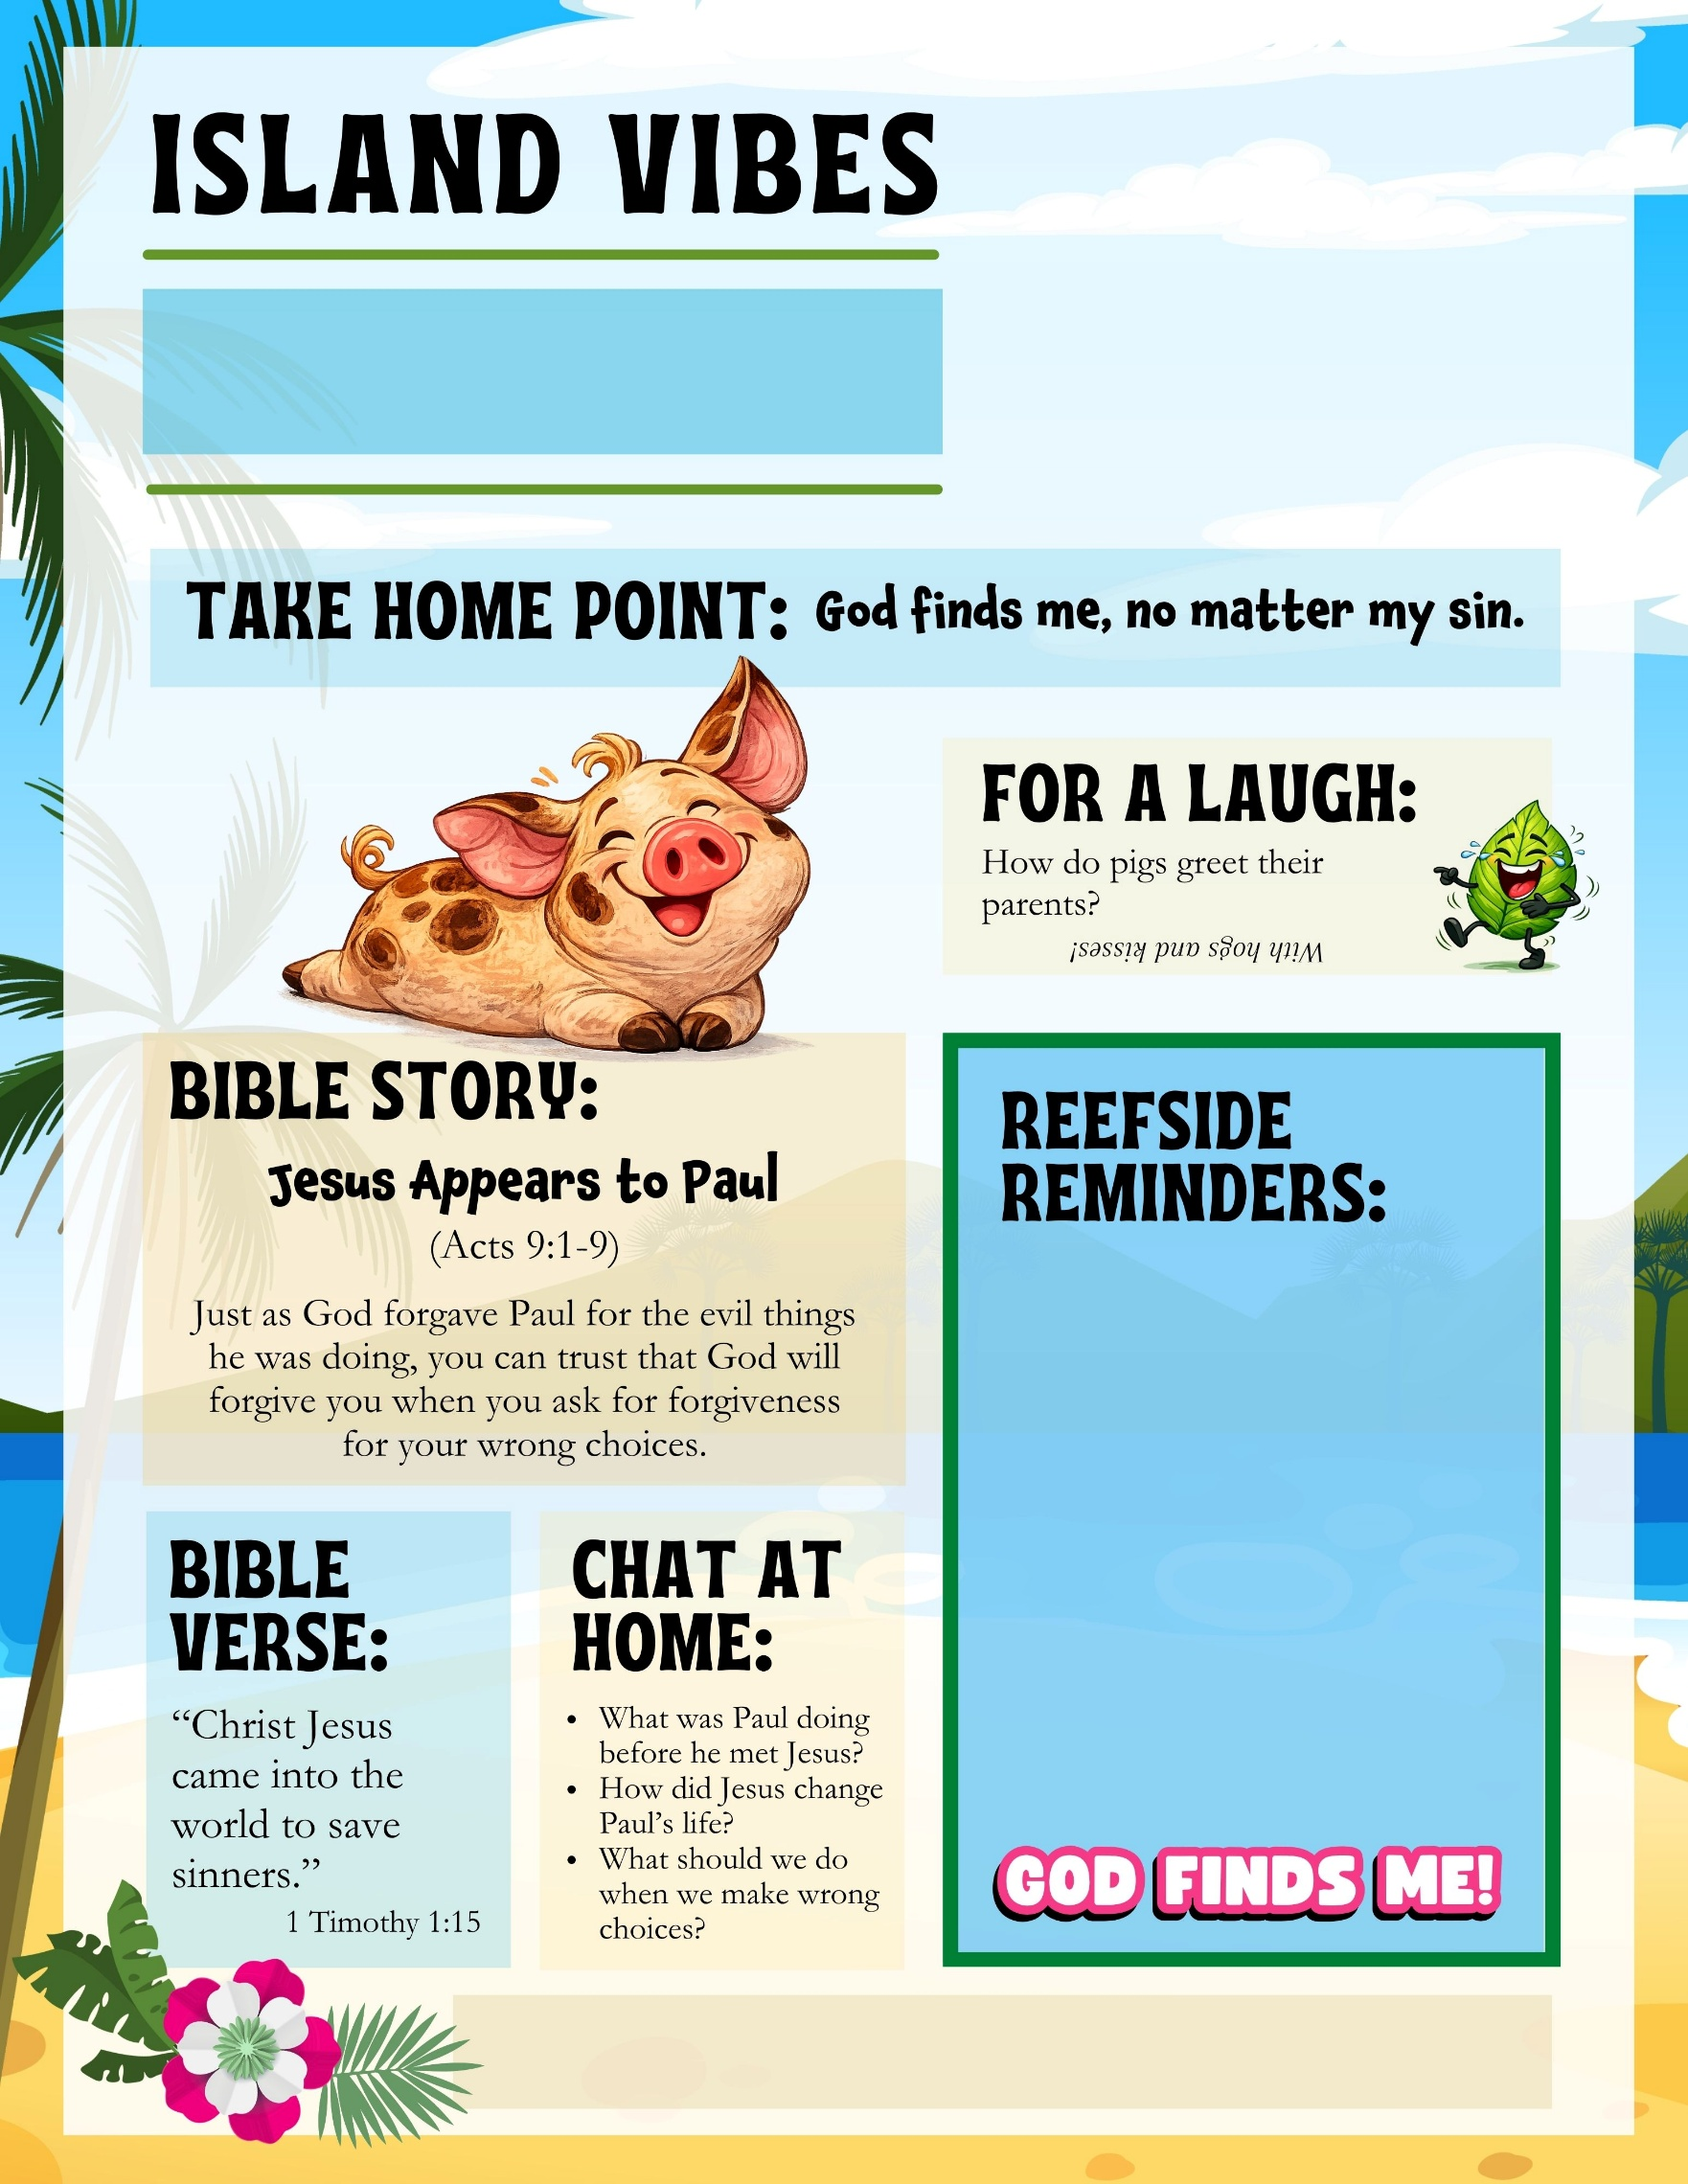
- Write important reminders for parents here…
- Announce your Celebration Sunday?
- Kids need to wear something special tomorrow? Let parents know.
- Remind parents about your missions project
Add your church name, website, phone, etc. here
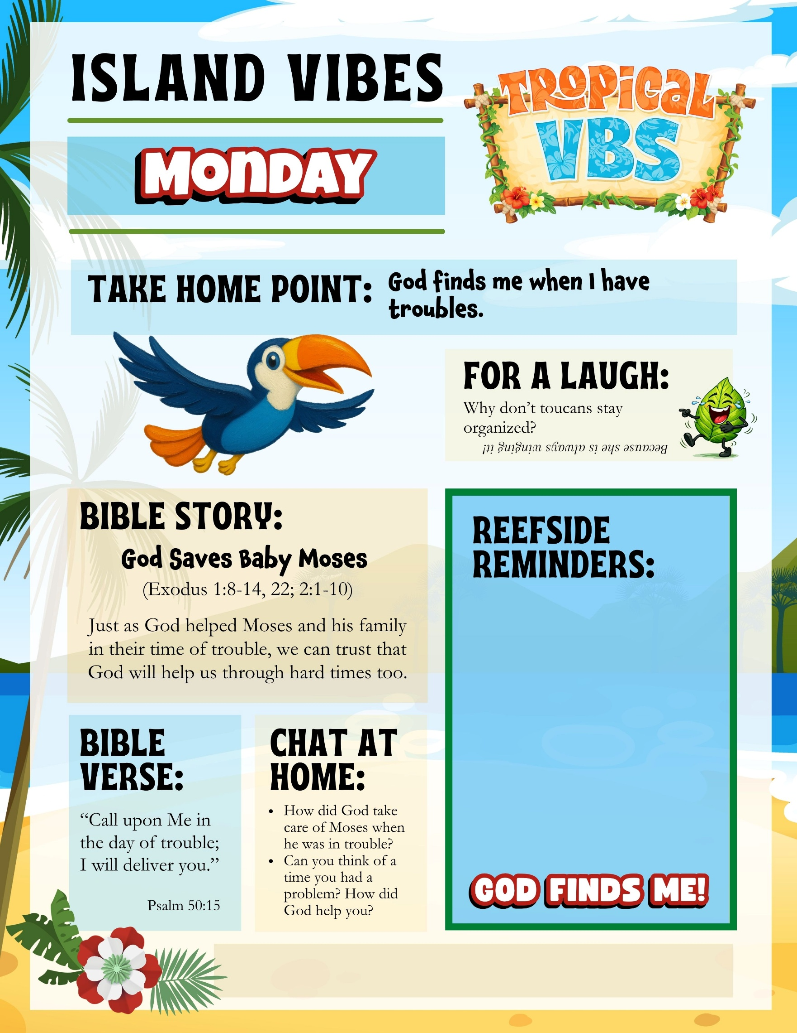
- Write important reminders for parents here…
- Announce your Celebration Sunday?
- Kids need to wear something special tomorrow? Let parents know.
- Remind parents about your missions project
Add your church name, website, phone, etc. here
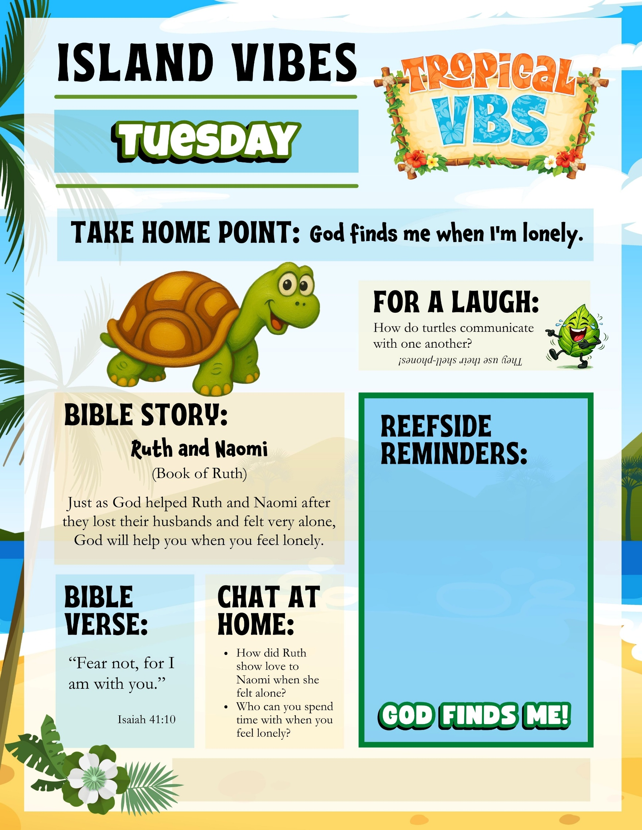
Add your church name, website, phone, etc. here
- Write important reminders for parents here…
- Announce your Celebration Sunday?
- Kids need to wear something special tomorrow? Let parents know.
- Remind parents about your missions project
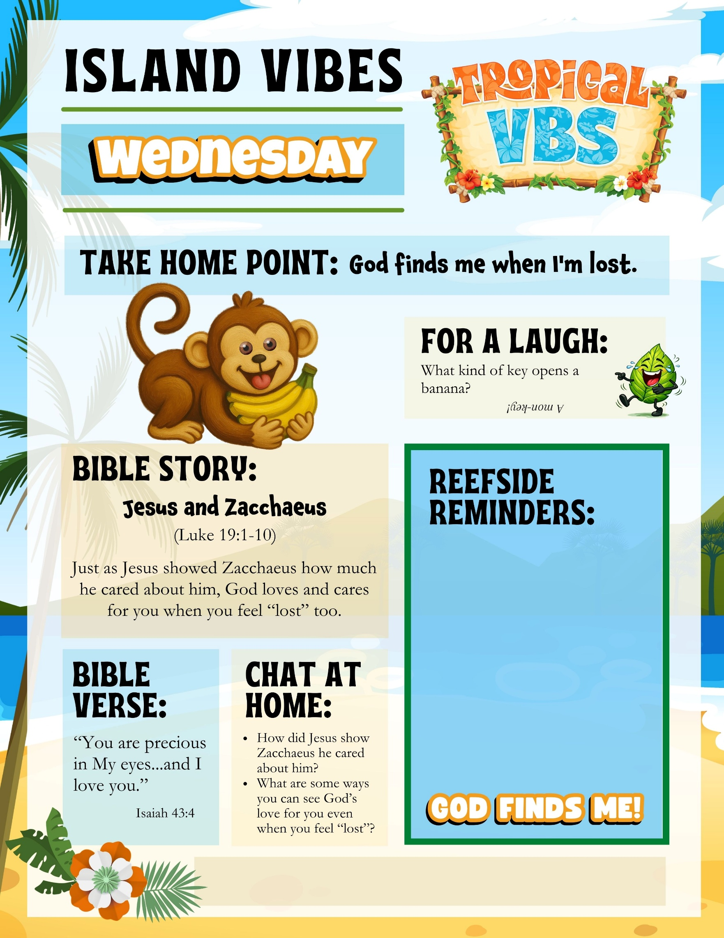
- Write important reminders for parents here…
- Announce your Celebration Sunday?
- Kids need to wear something special tomorrow? Let parents know.
- Remind parents about your missions project
Add your church name, website, phone, etc. here
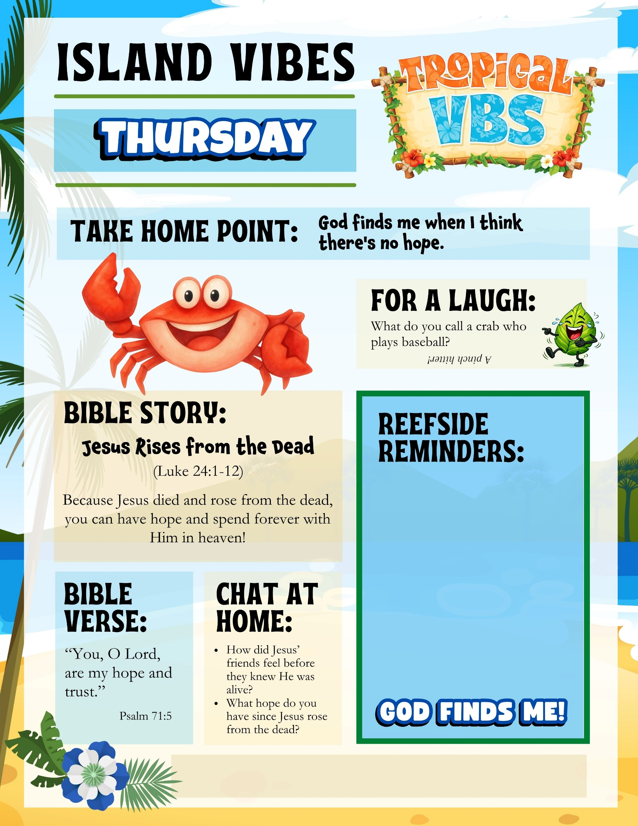
- Write important reminders for parents here…
- Announce your Celebration Sunday?
- Kids need to wear something special tomorrow? Let parents know.
- Remind parents about your missions project
Add your church name, website, phone, etc. here
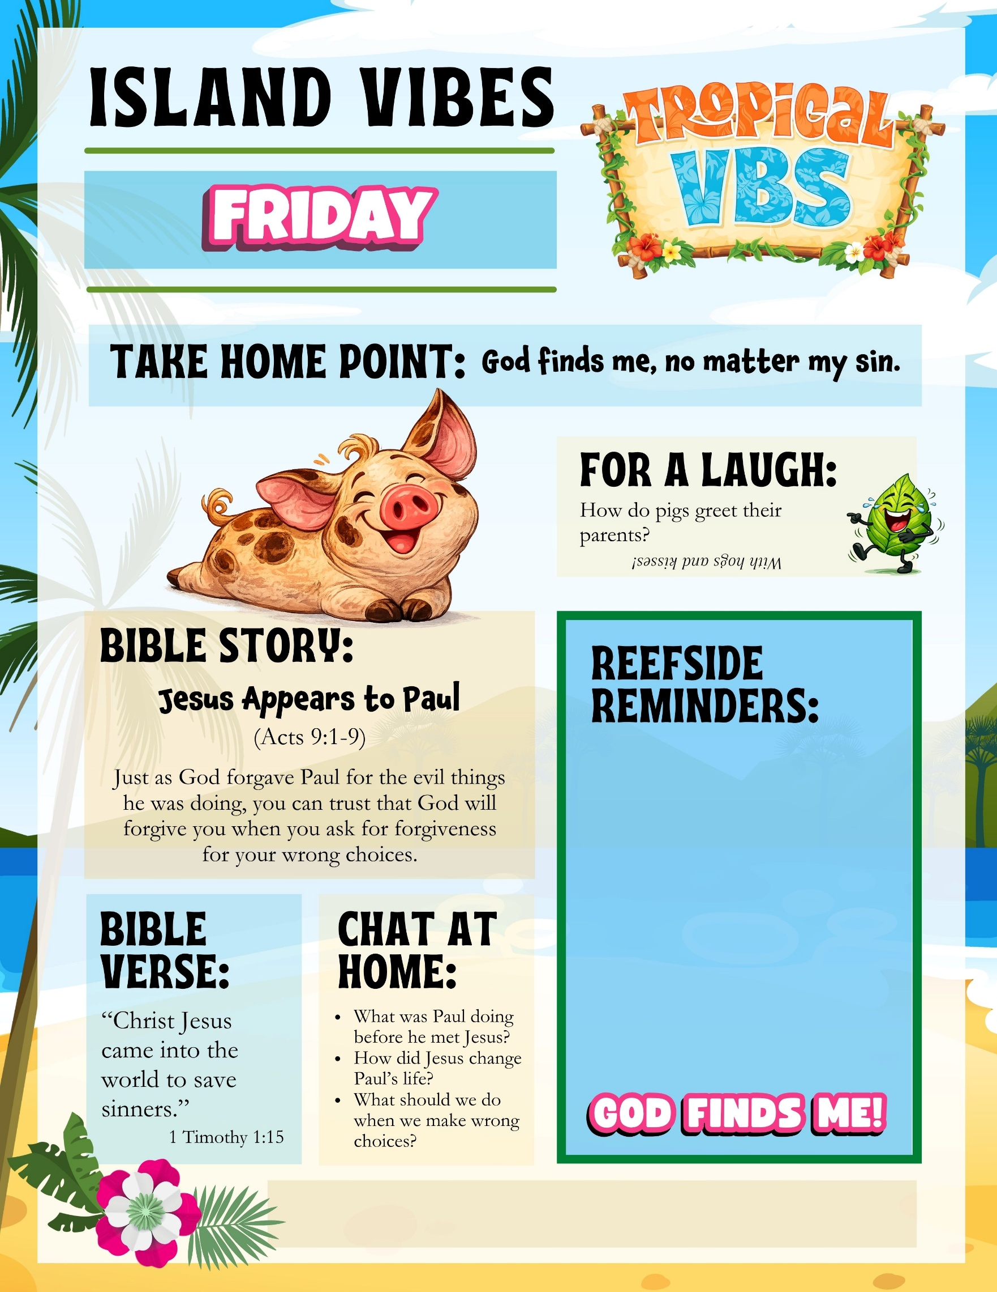
- Write important reminders for parents here…
- Announce your Celebration Sunday?
- Kids need to wear something special tomorrow? Let parents know.
- Remind parents about your missions project
Add your church name, website, phone, etc. here

