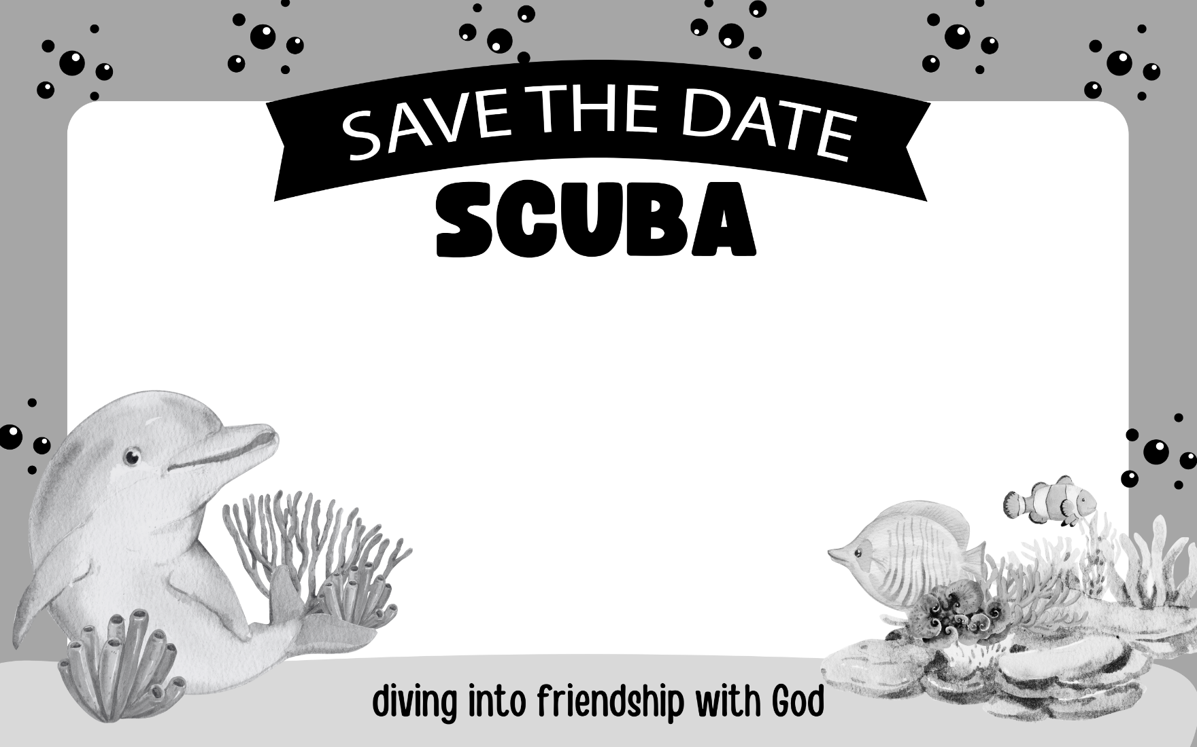
Enter your text here
Enter your text here

Enter your text here

Enter your text here

Enter your text here
Enter your text here
Enter your text here
Enter your text here

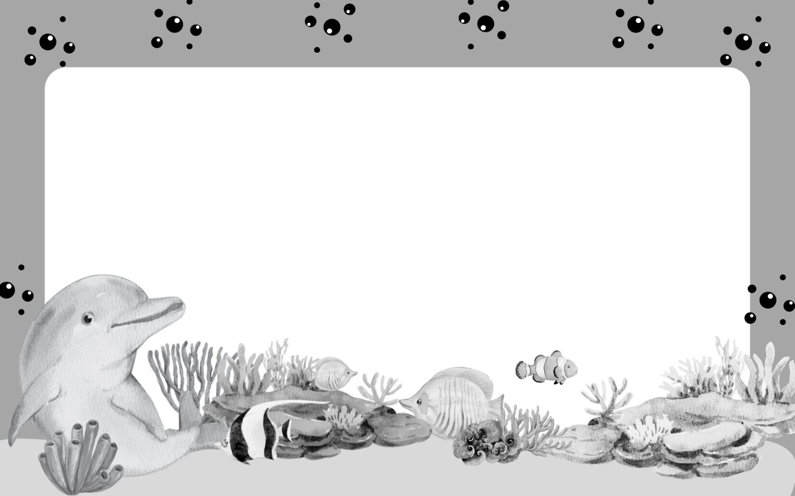
Enter your text here

Enter your text here

Enter your text here

Enter your text here
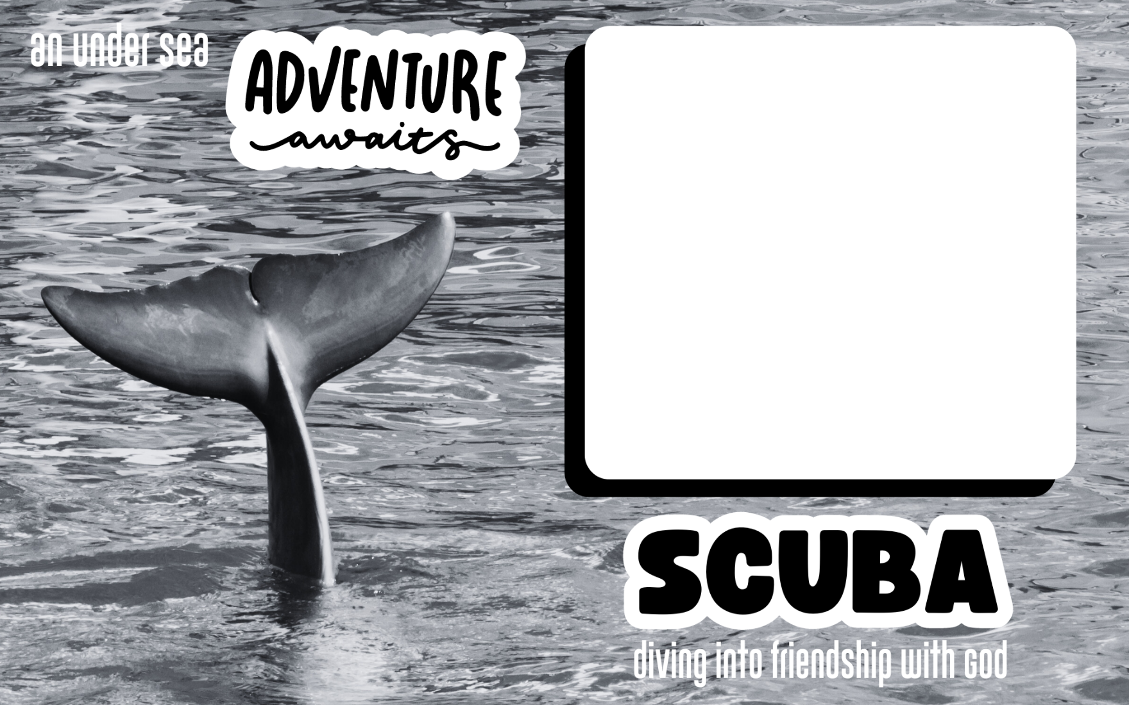
Enter your text here

Enter your text here

Enter your text here

Enter your text here
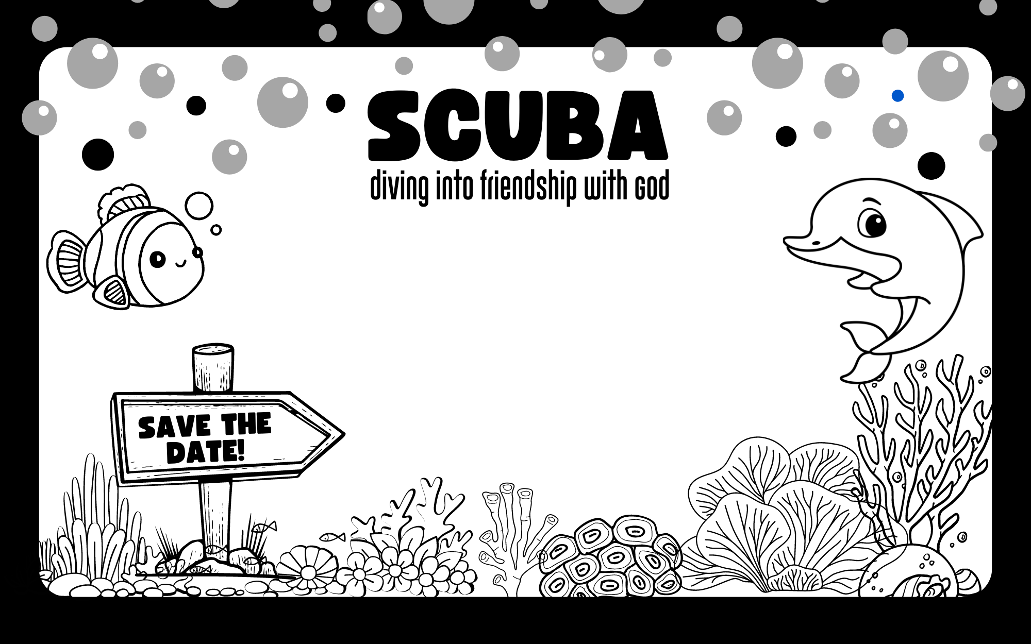
Enter your text here

Enter your text here
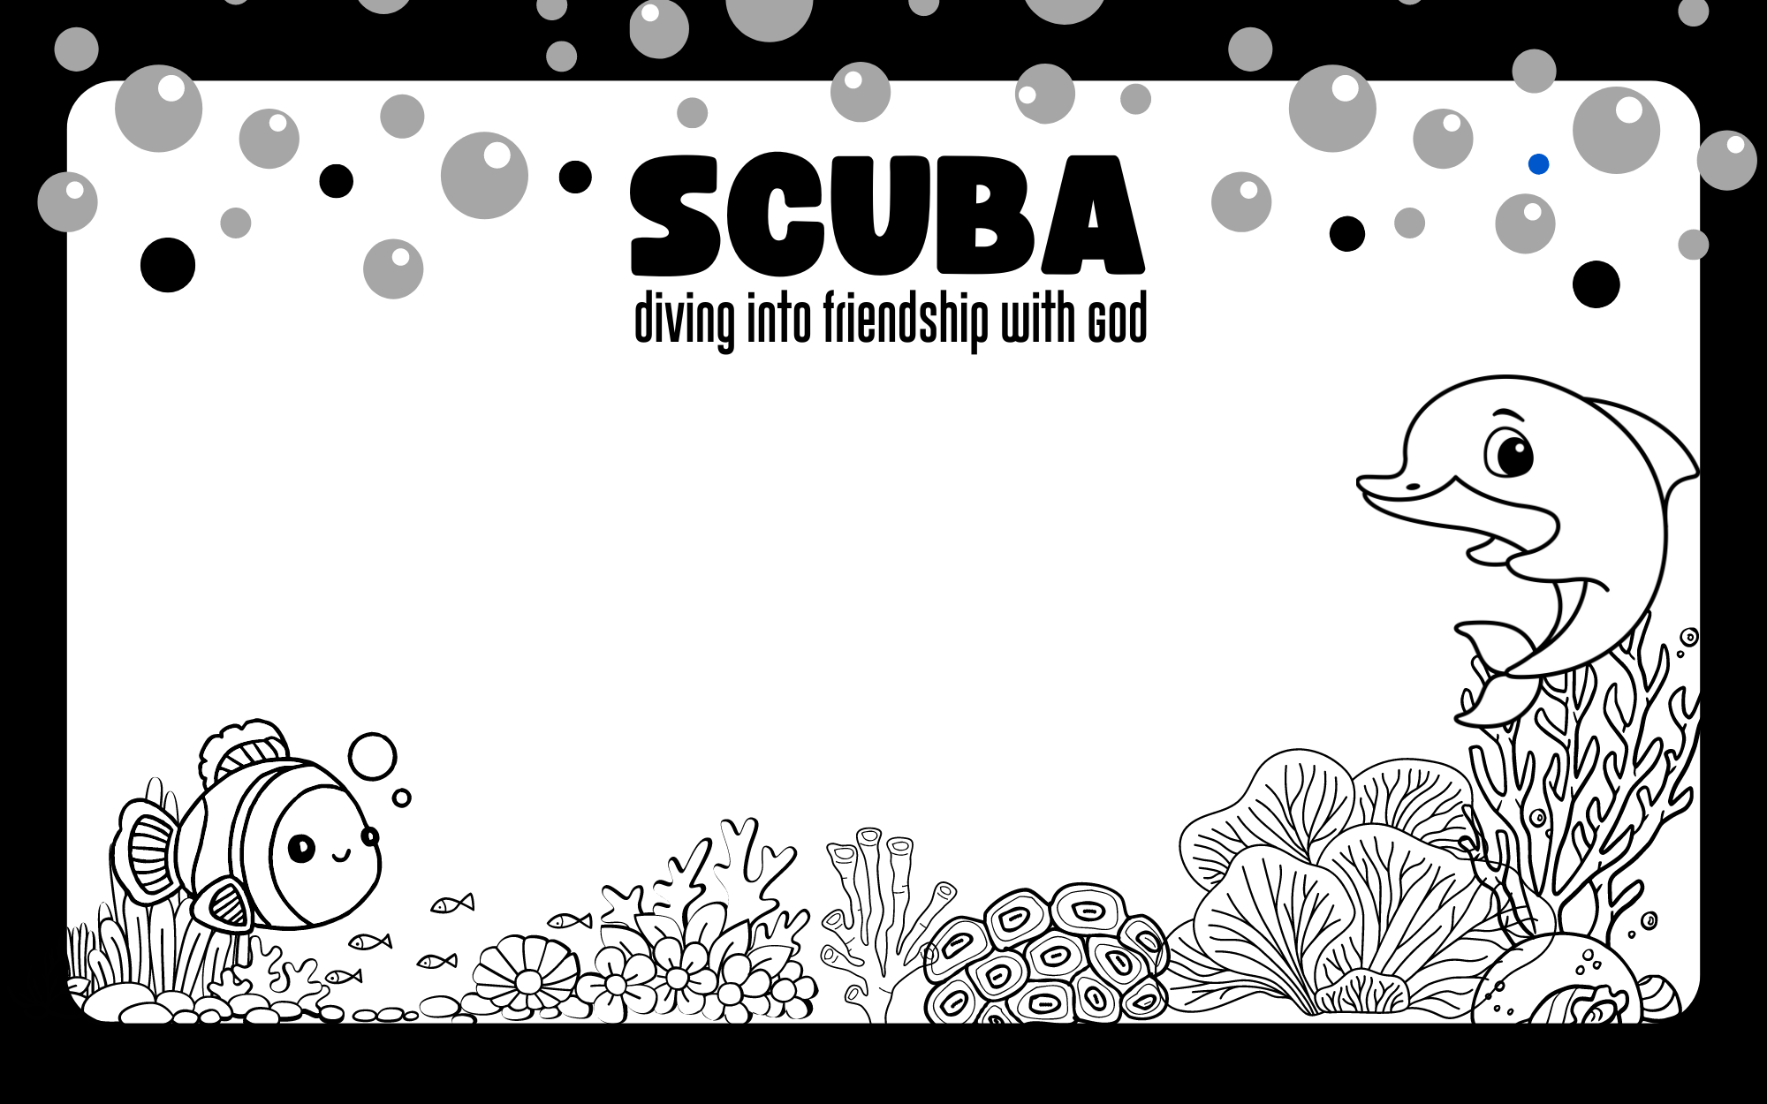
Enter your text here

Enter your text here
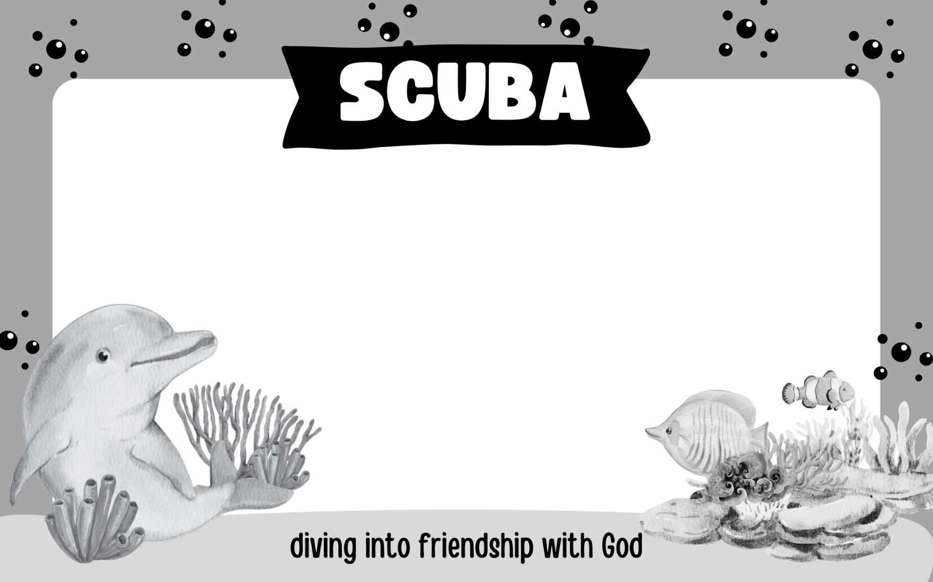
Enter your text here

Enter your text here
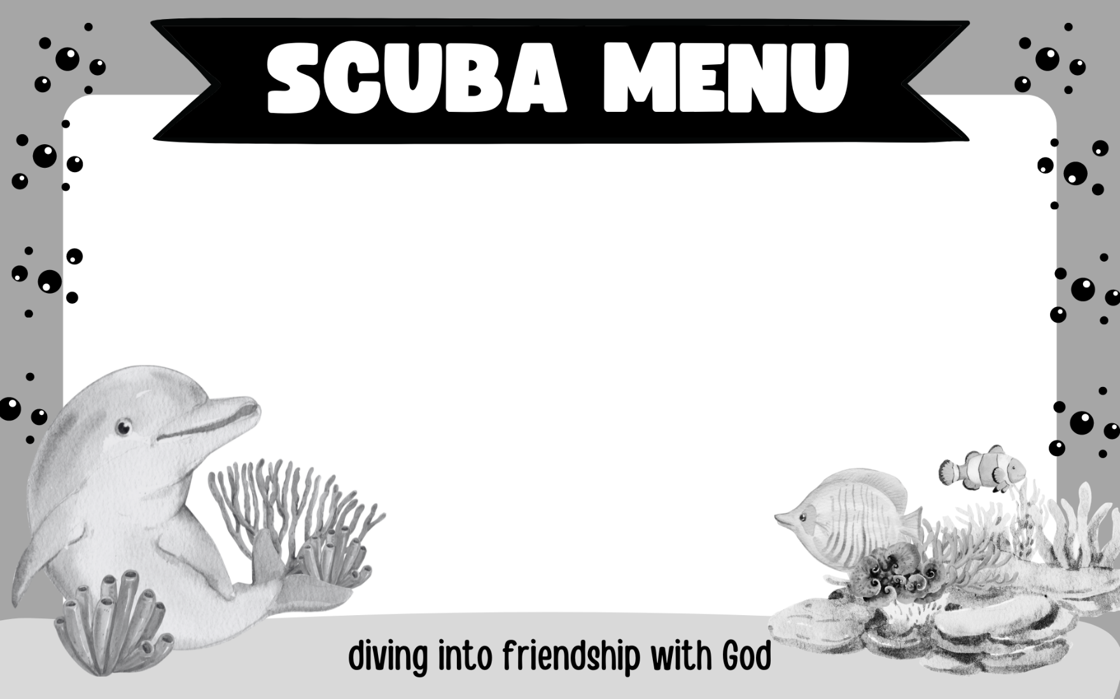
Enter your text here

Enter your text here
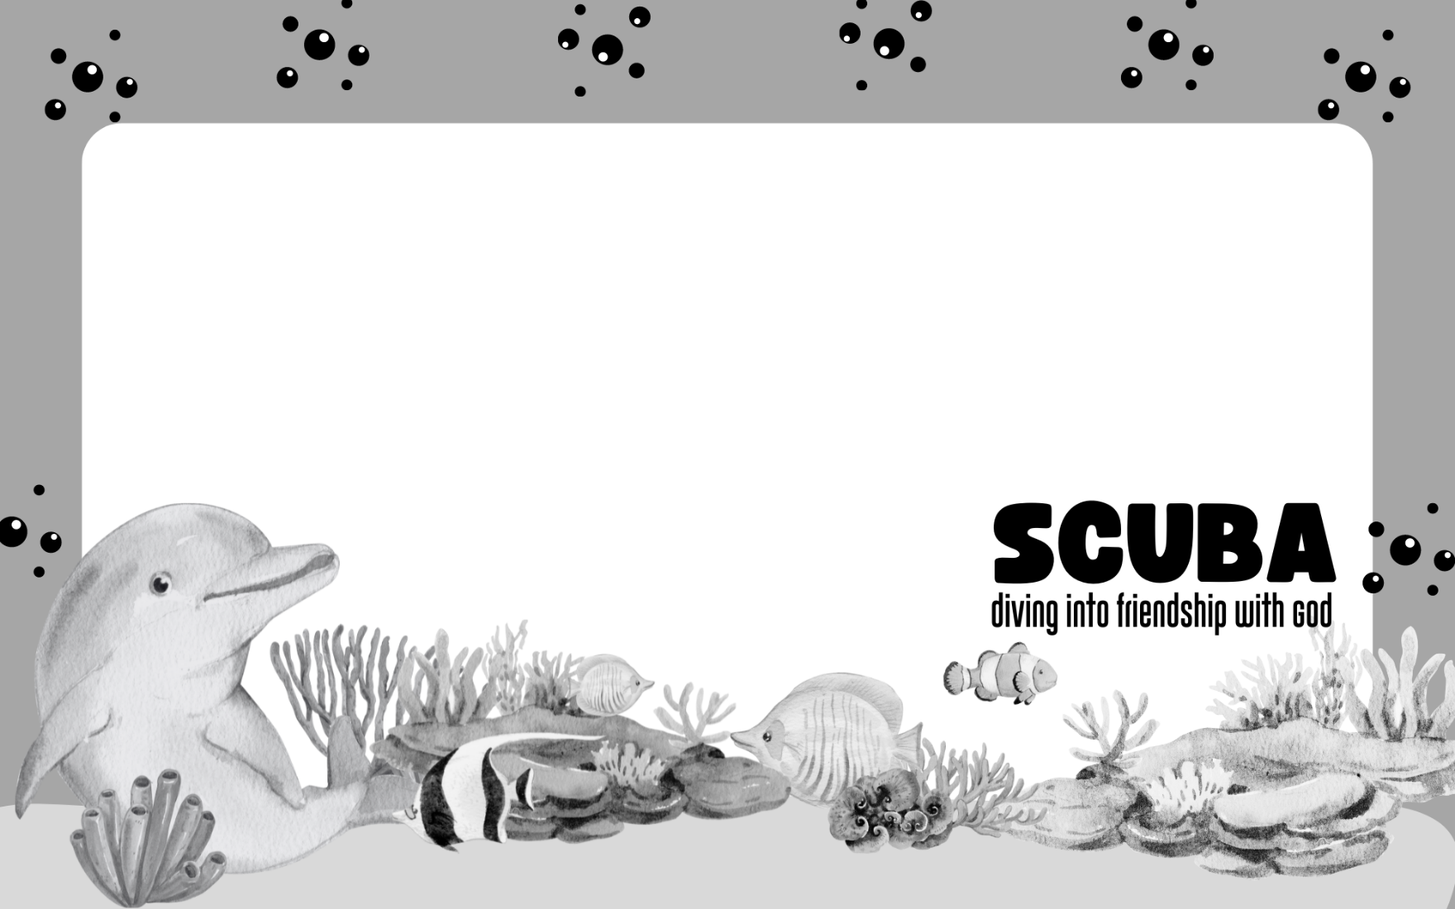
Enter your text here

Enter your text here

